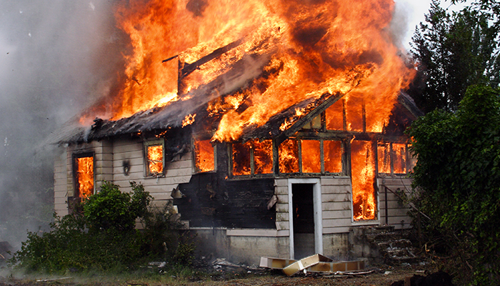**SPACE CAR KILLS INNISFAIL FAMILY IN CRASH FROM SPACE**

**SpaceX, Elon Musk’s space company sued for failed mission resulting in the deaths of an entire Innisfail family**

**A family of 6 has been tragically killed by a Tesla from space crashing into their house during the night of 20/4.**

**The famous car launched in 2018 and was supposedly being launched far away from the Earth to do space research but that was not the case**

**Experts say that the chances that the car hit a populated area is below one percent and that the trajectory and conditions had to perfect for the car to even land of Earth in the first place due to the objects burning while re-entering the atmosphere.**

**Mr Musk, founder of SpaceX has not made an apology to the relatives of the victims and is seemingly ignoring this horrible event killing 6 and injuring 9 more of the surrounding neighbours.**

**Police Reports say that the car entered the atmosphere at approximately twenty past ten in the night and that it is pursuing criminal charges for the scientists in charge of the project and demands answers about the reason this tragedy could be allowed to happen.**

**SpaceX is receiving a criminal lawsuit from the survivors and victim’s family alleging severe negligence leading to the deaths of innocent lives.**

**“I was eating dinner on Wednesday when I saw a flash of light coming from the window followed with the loudest sound, I have ever heard then my table shook violently. I immediately knew something was wrong but had idea of the extent of the damage until the next day” Reports Michael Hunter one of the surviving witnesses to the event.**

**SpaceX is yet to make a public comment on the matter but we have received reports that SpaceX is attempting the cover up the story and prevent it’s spread with targeted attacks on our organization.**